# STAMarker: Determining spatial domain-specific variable genes with saliency maps in deep learning

Chihao Zhang1, Kangning Dong2,3, Kazuyuki Aihara1,*, Luonan Chen4,5,6,7,* and Shihua Zhang2,3,5,*

1International Research Center for Neurointelligence, The University of Tokyo Institutes for Advanced Study, The University of Tokyo, Tokyo 113-0033, Japan

2NCMIS, CEMS, RCSDS, Academy of Mathematics and Systems Science, Chinese Academy of Sciences, Beijing 100190, China

3School of Mathematical Sciences/Sino-Danish College, University of Chinese Academy of Sciences, Beijing 100049, China

4Key Laboratory of Systems Biology, Shanghai Institute of Biochemistry and Cell Biology, Center for Excellence in Molecular Cell Science, Chinese Academy of Sciences, Shanghai 200031, China

5Key Laboratory of Systems Health Science of Zhejiang Province, School of Life Science, Hangzhou Institute for Advanced Study, University of Chinese Academy of Sciences, Hangzhou, 310024, China

6School of Life Science and Technology, Shanghai Tech University, Shanghai 201210, China

7Guangdong Institute of Intelligence Science and Technology, Hengqin, Zhuhai, Guangdong 519031, China

*To whom correspondence should be addressed. Tel/Fax: +86 01 82541360; Email: [kaihara@g.ecc.u-tokyo.ac.jp](mailto:kaihara@g.ecc.u-tokyo.ac.jp); [lnchen@sibs.ac.cn](mailto:lnchen@sibs.ac.cn); [zsh@amss.ac.cn](mailto:zsh@amss.ac.cn).

## Abstract

Spatial transcriptomics characterizes gene expression profiles while retaining the information of the spatial context, providing an unprecedented opportunity to understand cellular systems. One of the essential tasks in such data analysis is to determine spatially variable genes (SVGs), which demonstrate spatial expression patterns. Existing methods only consider genes individually and fail to model the inter-dependence of genes. To this end, we present an analytic tool STAMarker for robustly determining spatial domain-specific SVGs with saliency maps in deep learning. STAMarker is a three-stage ensemble framework consisting of graph-attention autoencoders, multilayer perceptron (MLP) classifiers, and saliency map computation by the backpropagated gradient. We illustrate the effectiveness of STAMarker and compare it with three competing methods on four spatial transcriptomic data generated by various platforms. STAMarker considers all genes at once and is more robust when the dataset is very sparse. STAMarker could identify spatial domain-specific SVGs for characterizing spatial domains and enable in-depth analysis of the region of interest in the tissue section.

**Keywords:** spatial transcriptomics, spatial domain, spatially variable genes, deep learning, saliency map

## Introduction

Knowing the relative spatial context of complex tissues or cell cultures is crucial to understanding complex biological systems(1). The recent advances in spatial transcriptomic (ST) technologies have enabled gene expression profiling with spatial localization information. Such techniques (e.g., 10x Visium(2), Slide-seq(3,4), and Stereo-seq(5)) can profile the gene expressions corresponding to captured locations (referred to as spots or beads) at a resolution of several cells or even at a subcellular level, allowing us to discover spatially variable genes(6–8), identify spatial domains(9–11)(i.e., regions with similar spatial expression patterns), deconvolve cell types of spots or beads(12,13), and characterize spatial cell-to-cell interactions (14,15).

One of the fundamental tasks in ST data analysis is to identify genes whose expressions display spatially varying patterns, simply referred to as spatially variable genes (SVGs). Common methods for identifying SVGs include trensceek (6), SpatialDE (7), SPARK(8), SPARK-X (16), and Hotspot (17). The first three methods were designed based on the parametric framework. For example, SpatialDE fits a Gaussian process regression (GPR) model for each gene’s expression and finds whether the GPR model with spatial terms describes data better than that without using a log-likelihood ratio test. Fitting GPR models for large-scale ST data can be very time-consuming. To address this issue, SPARK-X adopts a non-parametric framework to test the dependence between each gene’s expression covariance and spatial covariance. Hotspot adopts a spatial autocorrelation metric (i.e., a modified Geary’s C statistics) to construct a test statistic to identify SVGs. Similarly, MERINGUE (18) also uses the Moran’s *I* spatial autocorrelation metric to detect SVGs. Despite the statistical approach, researchers also address this problem for other perspectives. SpaGFT (19) transforms the gene expression into frequency signals and identifies SVGs based on the transformed frequency signals. SpaGCN (9) first identifies spatial domains by a graph convolutional network and then performs hypothesis test for each gene using spots from a target domain against a neighboring set of the target domain.

There are two main limitations of the existing methods. First, all the methods perform the hypothesis tests for each gene independently, ignoring the fact that the genes’ spatial expression patterns could be complementary to each other. Since ST data tend to be very sparse, performing hypothesis tests for genes individually may result in deteriorating performance. Second, the identified genes of most methods are not spatial domain-specific, hindering in-depth downstream analysis. For example, researchers may be interested in genes that display spatial patterns in one or several specific regions. However, most of the existing methods are not directly applicable for such a purpose.

To this end, we propose an analytic tool STAMarker based on a three-stage ensemble framework consisting of graph-attention autoencoders, multilayer perceptron (MLP) classifiers, and saliency map computation by the backpropagated gradient to determine robust spatial domain-specific SVGs. Different from testing genes individually as the existing methods, STAMarker considers all genes at once by the backpropagated gradient (i.e., saliency map) and further identifies the spatial domain-specific SVGs. The intuition behind STAMarker is that genes contributing most to the tissue structures are potentially important to the corresponding spatial domains. The prominent advantage of STAMarker is its ability to identify spatial domain-specific SVGs, enabling deeper insight into specific regions. Extensive experiments and the comparison with the existing methods SpatialDE, SPARK-X and Hotspot on various ST data generated from different platforms (e.g., 10x Visium(2), Slide-seq(3–5), and Stereo-seq(5)) have shown its effectiveness.

## Results

### Overview of STAMarker

STAMarker is a three-stage framework that consists of an ensemble of graph attention autoencoders (STAGATE(10)), an ensemble of MLP classifiers and saliency map computation by the backpropagated gradient (**Fig. 1**). More specifically, after constructing the spatial neighbor network (SNN) based on the spots’ locations, STAMarker first trains multiple STAGATE graph-attention autoencoders, each of which learns the low-dimensional embeddings of the spots. The learned low-dimensional embeddings are used to identify spatial domains with various clustering algorithms, such as Louvain(20) and mclust(21). To obtain robust and unified spatial domains, STAMarker uses consensus clustering to aggregate the clustering results. Second, STAMarker trains multiple MLPs to model the relationship between the corresponding embeddings and the spatial domains. Third, to detect the SVGs, STAMarker stacks the encoders with the corresponding MLP and computes the saliency maps by backpropagation (see the “Saliency score” subsection of the Methods). STAMarker selects the SVGs in each spatial domain by their norms in the saliency maps.

### STAMarker robustly identifies the spatial domain-specific SVGs on the human dorsolateral prefrontal cortex dataset

We first applied STAMarker to the human dorsolateral prefrontal cortex (DLPFC) dataset profiled by the 10x Visium platform(22). This dataset contains 12 sections that are manually annotated with the DLPFC layers and white matter (WM) based on the gene markers and morphological features (**Fig. 2A**). We considered the manual annotation as the ground truth and used the adjusted rand index (ARI) to evaluate the performance of spatial domain identification.

Compared with only using an individual graph attention auto-encoder, STAMarker improved the robustness and identified the spatial domains more accurately. For example, STAGATE resulted in an undesirable spatial domain in the DLPFC section 151507 (the red region in **Fig. 2A**, middle panel). STAMarker improved the performance of ARI from 0.48 to 0.55 and identified the expected cortical layer structures better. Experimental results in the 12 DLPFC sections showed that STAMarker could consistently reduce the model variances of STAGATE across all sections and improve the performance of spatial domain identification in most of the sections. Specifcally, the increase of the ensemble size enhance the robustness of both identifying spatial domains (**Fig. S1B**) and SVGs (**Fig. S1C**). In the following, we always set M=20 to balance robustness and computational efficiency.

STAMarker further identified the spatial domain-specific SVGs by saliency map. We note that a gene could be identified as an SVG for multiple spatial domains, which means that this gene is important for the determination of those spatial domains. For section 151507 of the DLPFC dataset, we found that 214 SVGs genes were specifically related to a unique spatial domain, and 382 SVGs were specifically with two or three spatial domains (**Fig. 2B**).

We compared STAMarker with six commonly used methods, i.e., SpatialDE(7), SPARK-X (16), and Hotspot (17), MERINGUE (18), SpaGFT (19) and SpaGCN (9). It should be noted that, except for SpaGCN, none of the compared methods can identify domain-specific spatially variable genes (SVGs). It is worth noting that spatially variable genes (SVGs) do not have a universally agreed-upon definition, and different methods used to identify them can have distinct underlying assumptions. In this study, we aim to address this challenge by examining the agreements between STAMarker and the compared methods. Additionally, we perform gene enrichment analysis and other downstream analyses to showcase the effectiveness of STAMarker in capturing spatial heterogeneity and identifying relevant biological patterns.

In order to facilitate a direct comparison, we maintained the same number of identified SVGs for all methods. However, SpaGCN only identified fewer than 20 SVGs in this dataset. We acknowledge that SpaGCN relies on performing hypothesis tests on the spatial domain of interest against neighboring domains. Given the sparsity of spatial transcriptomic data, the power of the hypothesis test is significantly weakened. In the SpaGCN paper, it typically identified several dozens of SVGs on this dataset, which is considerably fewer compared to statistical-based methods like SPARK-X and Hotspot. The UpSet plot in **Fig. 2C** illustrates a relatively high agreement among the identified SVG sets by the six methods, with 181 out of 650 genes being identified by all methods (referred to as *consensus SVGs*). It is important to note that the agreements across different methods vary depending on factors such as sequencing platforms, tissue types, and other inherent biological factors. For more detailed information on the agreements among the compared methods, please refer to the **Supplementary Notes** section **“Agreements of the identified SVGs across the compared methods”**.

To further illustrate the robustness of STAMarker, we downsampled the counts of the gene expressions and computed the overlap number of the identified SVGs with the *consensus SVGs* (**Fig. 2D**). STAMarker is more robust than other methods when the gene expressions are sparse (the downsampling rate is less than 0.2). The compared methods perform the hypothesis test for each independently, resulting in weak statistical power when the data are very sparse.More importantly, STAMarker could determine spatial domain-specific SVGs that play important roles in DLPFC (**Fig. 2E**). We note that a gene that is highly expressed in a spatial domain does not necessarily have a higher saliency score in that region. For example, *CD47* was highly expressed in more than one layer, and it was identified as a layer 1-specific SVG by STAMarker but not by other methods. Note that *CD47* was known as the ligand of tyrosine phosphatases(23), and was documented as an Alzheimer’s resilience factor(24) which is related to the biological function of DLPFC. Moreover, STAMarker revealed *FEZF2* and *HAPLN2* as layer 5 and WM-specific genes respectively. Notably, *FEZF2* is a marker gene of deep layer excitatory neurons(25), and *HAPLN2* plays an important role in the development of white matter(26). In a sense, STAMarker implicitly considers gene expression interactions by simultaneously considering all genes through backpropagation of gradients. To illustrate this, we present boxplots of the raw counts and the reconstructed gene expressions using the autoencoders for three selected spatially variable genes (**Fig. S2A**). It is evident that the raw counts in each domain are predominantly zeros, posing challenges for individual gene-based hypothesis testing. Conversely, the reconstructed expressions of the selected genes are overexpressed in their corresponding spatial domains, providing rationale for the effectiveness of STAMarker. Lastly, STAMarker also revealed some SVGs like *MOBP*, *MBP,* and *SNAP25* for multiple spatial domains, which have been reported as marker genes before(22).

The saliency map can be used to cluster the spatial domain-specific SVGs into spatial modules (see the “**Identifying spatial domain-specific SVG modules**” subsection). The selected SVGs were clustered into seven clear modules (**Fig. S1D**) which correspond to the layers 1-6 and white matter, respectively (**Fig. S1E**). We also performed gene enrichment analysis for the identified SVGs by the seven methods and found that the SVGs identified by STAMarker tended to be more enriched in GO cellular components (GO:CC) terms directly related to the nervous system, such as synapse and neuron projection (**Fig. S1E**). We observed consistent phenomena in other datasets (see Supplementary Notes section “**Comparison of the enrichment analysis of the identified SVGs**” for detailed description).

### STAMarker enables fine-grained analysis on the mouse hippocampus dataset of Alzheimer’s disease

We applied STAMarker to the mouse hippocampus dataset of Alzheimer’s disease (AD)(27), which was generated by Slide-seq V2 with a spatial resolution of 10μm. STAMarker could well characterize the tissue structures (**Fig. 3A**) including the important ones in the hippocampus, such as the arrow-like structure DG and the cord-like structure CA1. STAMarker successfully identified a spatial domain (domain 9) corresponding to the microglial cells (**Fig. 3B**), which were concentrated around amyloid plaques. This phenomenon is a prominent feature of AD(28,29). STAMarker identified the SVGs of spatial domain 9, and many of them are known gene markers of microglial cell and risk genes of AD with significantly high expressions (**Fig. 3C**). For example, *P2ry12* was related to microglial motility and migration(30); *Trem2* was known selectively expressed by microglia and related to a cell surface protein(29). *Trem2* was also a well-known risk gene associated with AD, and its mutation increases the risk of AD around threefold(31,32). *Hexb* and *Cx3rc1* were stably expressed microglia core genes(33). Among the competing methods, SpatialDE missed *Hexb* and *Fcrls*, SpaGFT identified *Mef2c* and *Hexb*, SPARK-X only identified *Mef2c*, and the rest three methods, i.e., Hotspot, MERINGUE and SpaGCN successfully identified all the six known marker genes as well. Compared with the competing spatial domain-agnostic methods, STAMarker enables a fine-grained analysis of the spatial domain of interest.

In total, STAMarker determined 797 SVGs that had considerable overlap with the ones identified by other methods and many of the STAMarker-identified SVGs are domain-specific (**Fig. S3A**). These SVGs detected by STAMarker were enriched in a total of 1125 GO terms and 47 KEGG at an FDR of 5%. The directly related GO terms such as synapse (GO:0045202), nervous system development (GO:0007399), and neuron projection (GO:0043005) were significantly enriched and comparable to the competing methods (**Fig. S2C**).

We further used the saliency map to cluster SVGs belonging to fewer than two spatial domains (referred to as domain-specific SVGs for simplicity) into nine gene modules (**Fig. 3D**, 312 SVGs in total). Gene module M1 (74 genes) was highlighted in the microglial cells and was specifically enriched in many GO terms related to the immune response terms, such as immune system process, response to stimulus, and regulation of cytokine production (**Fig. 3F**). As a comparison, the enriched GO terms of gene module M5 were mainly related to transmembrane transport and no immune-related GO terms were detected. The representative genes of gene module M1 include *Egr3, Lrrn2, and Kcnb1* (**Fig. 3G**). *Egr3* was CA3-specific and only identified by STAMarker. *Egr3* was known as a master regulator of differentially expressed genes in AD(34). *Lrrn2* corresponded tomicroglial and CA1. *Kcnb1* was a DG-specific one, indicating that it is important for distinguishing DG from other spatial domains. *Kcnb1* was also associated with aging and cognitive impairment(35). Gene module M2 (37 genes) was mainly highlighted in the exterior region with two representative genes *Usp33* and *Tenm2*. This module was significantly enriched in axon growth(GO:0007409, $P=3.55×{10}^{-26}$) and axon guidance (GO:0007411, $P=2.74×{10}^{-10}$). Gene module M5 (30 genes) was enriched in many GO terms related to neurons such as regulation of neurotransmitter levels (GO:0001505, $P=5.78×{10}^{-23}$), and presynapse (GO:0098793, $P=2.85×{10}^{-57}$). Its representative gene *Gad2* was a spatially variable one related to spatial domains 4 and 7 (**Fig. 3G**).

### STAMarker reveals the domain-specific variable genes on the mouse olfactory bulb dataset

We applied STAMarker to the mouse olfactory bulb dataset(5) profiled by the Stereo-seq platform to identify the laminar organization and the corresponding SVGs. STAMarker could well decipher the eight spatial domains with clear laminar structures (**Fig. 4A**), consisting of rostral migratory stream (RMS), ependymal cell zone (ECZ), granule cell layer (GCL), internal plexiform layer (IPL), mitral layer (MT), glomerular layer (GL) and olfactory nerve layer (ONL), annotated according to the Allen Brain Atlas(36).

STAMarker determined 311 SVGs, and most of them belong to more than three spatial domains (**Fig. 4B**), implying that the eight laminar organizations share similar gene expression patterns. The shared SVGs of the four methods is only one gene (**Fig. 4C**). The SVGs identified by STAMarker were enriched in more GO terms and KEGG pathways, while those of SpatialDE were enriched in much fewer terms at an FDR of 5% (**Fig. S4**) (STAMarker: 451 GO terms and 42 KEGG pathways; Hotspot: 349 GO terms, 27 KEGG pathways; SPARK-X: 377 GO terms, 34 KEGG pathways; SpatialDE: 15 GO terms, 2 KEGG pathways; MERINGUE: 181 GO terms, 9 KEGG pathways; SpaGFT: 170 GO terms, 9 KEGG pathways; SpaGCN: 165 GO terms, no KEGG pathwary are enriched). Many of the STAMarker-identified GO terms and KEGG pathways directly related to the synapse organization and the functions of the olfactory bulb, and tended to be more significant than those of the other methods. For example, the SVGs identified by STAMarker were enriched in the circadian entrainment pathway (KEGG 04713, $P=4.13×{10}^{-12}$) and were more significant than those by the compared methods (Hotspot $P=3.05×{10}^{-7}$; SPARK-X $P={10}^{-6}$; SpaGFT, SpatialDE, MERINGUE and SpaGCN are not significant).

The spatial domain-specific SVGs (67 genes) were clustered into eight gene modules (**Fig. 4D**), showing clear laminar organization with distinct correspondence to the morphological layers. For example, gene module M1 consisted of spatial domain-specific SVGs of the ECZ and GCL layers (**Fig. 4E**). Its two representative genes *Fasn* and *Cabin1* were, respectively, related to the endothelial cell differentiation (GO 0045446, $P=6.60×{10}^{-3}$) and over-expressed in olfactory epithelium(37) (**Fig. 4F**), which was only identified by STAMarker. Gene module M3 highlighted the interior layers of the olfactory bulb with two typical genes: *Gad1* was highlighted in both GCL and IPL and played an important role in the olfactory bulb interneurons(38) and *Pcp4l1* was known as a marker gene of the GCL(39). Gene module M4 mainly corresponded to the IPL and EPL spatial domains with two typical genes *Slc25a3* and *Cox7a2*, and was enriched in the organelle inner membrane (GO 0019866, $P=6.91×{10}^{-8}$)*.*

### STAMarker uncovers the spatial domain-specific SVGs on the mouse cerebellum dataset

We illustrated the effectiveness of STAMarker on a mouse cerebellum dataset generated by Slide-seq V2 platform(40). STAMarker clearly identified the tissue structures of the cerebellum, i.e., molecular layer (MOL), Purkinje layer (PL), white matter (WM) and granule cell layer (GCL), and cerebellar nucleus (CN) (**Fig. 5A**). STAMarker and other six methods determined 508 SVGs respectively and the SVGs identified by SpatialDE were quite different from those of other methods (**Fig. S4**). The SVGs identified by STAMarker were enriched in 640 GO terms and 30 KEGG pathways, while the SVGs identified by SPARK-X were enriched in 578 GO terms and 32 pathways (for comparison, Hotspot: 550 GO terms and 24 KEGG pathways; MERINGUE: 363 GO terms and 7 KEGG pathways; the rest of the compared methods were enriched less than 300 GO terms and 10 KEGG pathways) (**Fig. S4C**). STAMarker identified the GO terms that are directly related the cerebellum development (GO 0021549, $P=3.59×{10}^{-4}$) and morphogenesis (GO 0021587, $P=4.83×{10}^{-4}$), while Hotspot is the only method that identified the two GO terms with less overlap size (GO 0021549, $P=5.67×{10}^{-3}$; GO 0021587,). One of the prominent advantages of STAMarker is the ability to provide spatial domain-specific SVGs, enabling more fine-grained analysis. Moreover, the spatial domain-specific enrichment analysis characterized the functions of each spatial domain. For example, the Purkinje-related GO terms were only enriched in MOL, PL, and GCL respectively (**Fig. 5B**), which is consistent with the histology of Purkinje cells.

Moreover, the SVGs determined by STAMarker could cover more mouse cerebellum marker genes from the Harmonizome database(41) (i.e., 108 out of the 261 genes) with the hypergeometric test $P=5.29×{10}^{-23}$ compared to the other three methods (**Fig. 5C**). MERINGUE identified the second most 80 genes with the hypergeometric test, while the overlaps of the identified SVGs by SPARK-X and SpatialDE were merely below 50 without statistical significance.

The spatial domain-specific SVGs were clearly clustered into five gene modules based on the saliency maps (**Fig. 5D**) with clear spatial domain patterns (**Fig. 5E**). The five modules were enriched in distinct cell types (**Fig. 5F**) based on the downloaded marker genes of cerebellum-related cell types from PanglaoDB(42). For example, gene module M1 corresponds to GCL and MOL with two representative genes *Cbln1* and *Dab1.* The two genes were strongly over-expressed in the corresponding spatial domains and were enriched in cerebellum development (GO 0021549, $P=4.13×{10}^{-8}$). *Cbln1* was essential for synaptic plasticity and integrity in the cerebellum(43). Gene module M2 mainly consists of PL and MOL and the Purkinje neurons were only enriched in this module. Two example genes of M2 include *Gria1* and *Baiap2* belonging to the enriched GO term regulation of synaptic plasticity (GO 0048167, $P=3.49×{10}^{-9}$). In particular, *Baiap2* was only identified by STAMarker. Gene module M5 was related to the CN and WM spatial domains with two highly expressed genes *Nrsn1* and *Ucn* in the CN region. Moreover, both of them were in the enriched GO term distal axon (GO 0150034, $P=3.88×{10}^{-19}$). In summary, STAMarker can not only determine SVGs that are enriched in the most GO terms and KEGG pathways that are directly related to the tissue biological functions compared to other methods, but also provides the spatial domains corresponding to SVGs.

## Discussion

Determining SVGs is the very first step towards understanding the complex biological functions of complex tissues and cell cultures through ST data. Here, we develop a robust and effective spatial domain-specific SVGs identification method STAMarker. STAMarker is a three-stage analytic method inspired by the saliency map in deep learning. STAMarker conceptually considers genes that contribute most to the determination of the spatial domains as SVGs. Different from the competing methods that consider genes independently, STAMarker considers all genes simultaneously, making it possible to exploit the complementary information across genes. Another outstanding advantage of STAMarker is its ability to identify spatial domain-specific SVGs while the competing methods are not directly applicable.

STAMarker could robustly identify SVGs even when the data are downsampled to a very sparse level. Experimental results on various datasets consistently showed that SVGs identified by STAMarker tended to be more significant in related GO terms and KEGG pathways. Moreover, the spatial domain-specific SVGs can be organized into gene modules corresponding to spatial domain patterns. The domain-specific SVGs identified by STAMarker could also enable researchers to investigate spatial domains of interest at a finer scale.

Although we initially demonstrated the effectiveness of STAMarker primarily on well-structured brains, our results indicate its capability to identify SVGs even in complex datasets such as lymphoid organs. We further applied STAMarker onto a human lymph node dataset. STAMarker analysis (**Fig. S8** and **Supplementary Notes** section “**10x Visium human lymph node dataset**”) revealed complex spatial domains, aligning with a previous study (44). Further clustering of STAMarker-identified SVGs into gene modules highlighted specific marker genes for B cells and T cells (e.g., *MS4A1*, *GZMB*). Additionally, compared to other methods, STAMarker and SpaGCN identified a greater number of marker genes associated with the immune system using a downloaded reference gene list from PanlaoDB (42).

In this study, we mainly focused on the sequencing-based ST data. To showcase the model’s robustness, we further applied STAMarker onto an image-based data of mouse visual cortex generated by the STARmap (45) technology (**Fig. S9**). This dataset profiles 1020 genes of 1207 cells at single cell resolution. Consistent with the results on sequencing-based datasets, STAMarker improved the performance of spatial domains identification (ARI=0.574) compared with only using one auto-encoder (ARI=0.548). In addition, STAMarker identified gene modules demonstrating clear spatial patterns.

Despite that STAMarker considers all genes simultaneously and measures genes’ importance by their contributions to the classification, it is still unclear how to evaluate the importance of a set of genes, which are expected to be solved in the future. STAMarker trains multiple graph attention autoencoders to enhance its robustness. Data-oriented ensemble inference, such as using different subsets of highly variable genes and spots, will enhance the model diversity, but also require training more models to obtain robust results. It is worthy of investigating how to introduce the data-oriented ensemble inference and still maintain computational efficiency in future work. Lastly, we expect that this kind of analytic tool can be extended to other spatial omics like spatial metabolomics(46).

## Materials and Methods

### Data description

We applied STAMarker and the three compared methods to ST datasets generated by various techniques, including 10x Visium, Slide-seqV2, and Stereo-seq (see **Supplementary Table S1** for details).

### Data preprocessing

We followed the data preprocessing procedure in STAGATE(10). We first removed spots outside of the main tissue area. We then used the pipeline provided by the SCANPY package to log-transform the raw gene expression and normalize it according to the library size. For all datasets, we selected the top 3,000 highly variable genes as the inputs of STAMarker.

### Ensemble of graph attention auto-encoders

We used an ensemble of graph attention auto-encoders to robustly identify spatial domains. We adopted STAGATE as the base auto-encoder for its superior performance in spatial domain identification. Specifically, STAGATE consists of three parts: encoder $f_{enc}$, decoder $f_{dec}$ and the attention layer. STAGATE first constructs a spatial neighbor network (SNN) where neighboring spots have edges. The encoder $f_{enc}$ transforms the gene expression of a spot into a *d*-dimensional embedding by aggregating information from the neighboring spots in SNN. Let’s denote the gene expression matrix of n spots and p genes by. The l-th layer of the encoder outputs the embedding of spot i as follows

|  |  |  |
| --- | --- | --- |
|  | | (1) |

where is trainable weight matrix, is the edge weight between spot and in the graph attention layer, and is the neighboring spots in SNN (including spot itself). The initial spot embeddings are set as the gene expression profile, i.e., The encoder’s layer outputs the embedding by aggregating information from neighboring spots in SNN and the coupled attention layers adaptively learn the edge weights. The L-th layer encode outputs the final embedding of spot as and then the decoder reverses back the latent embedding into the reconstructed gene expression profile, i.e.,.

Despite that STAGATE has shown its effectiveness on various ST datasets, an inherent challenge of deep learning methods is that the weight initialization might have a significant impact on the results. To alleviate this issue, we constructed an ensemble of graph attention auto-encoders. We trained $M$ STAGATE models with different random weight initialization and applied clustering algorithms to the learned low-dimensional embeddings of each model. Specifically, we used the mclust clustering algorithm when the number of labels is known; otherwise, we employed the Louvain algorithm. As a result, we obtained $M$ clustering results for each STAGATE model, denoted by $Y^{(1)}$, $Y^{(2)}$, …, $Y^{(M)}$, respectively.

### Consensus clustering

We use consensus clustering to obtain the spatial domains. Given the clustering results $Y^{(1)}$, $Y^{(2)}$, …, $Y^{(M)}$, we first compute the clustering connectivity matrix

$C$ such that

|  |  |  |
| --- | --- | --- |
|  | $$C_{ij}=\frac{\sum_{m=1}^{M}{I(y_{i}^{\left(m\right)}=y_{j}^{\left(m\right)})}}{M},$$ | (2) |

where $I(⋅)$ is the indicator function, and $y_{i}^{\left(m\right)}$ and $y_{j}^{\left(m\right)}$ denote the cluster labels of spots $i$ and $j$ in $Y^{(m)}$, respectively. The numerator of Equation (2) represents the times of spots and belonging to the same spatial domain in clustering results. Hence, the clustering connectivity matrix $C$ is a symmetric matrix where $C_{ij}$ indicates the empirical probability of spots $i$ and $j$ that belong to the same cluster. Finally, we applied hierarchical clustering to $C$ and obtained the spatial domain labels $Y^{*}$. The number of clusters $K$ is simply set as the same as the mode of the number of clusters of the $M$ clustering results when using the Louvain algorithm.

### Ensemble of MLP classifiers

We used an ensemble of two-layer MLP classifiers denoted by $f_{MLP}$ to model the relationship between the latent embeddings and the spatial domain labels $Y^{*}$. The low-dimensional latent embeddings of the $M$ auto-encoders are used as the inputs:

|  |  |  |
| --- | --- | --- |
|  | $$f_{MLP}\left(h_{i}\right)=σ\left(W_{2}σ\left(W_{1}h_{i}+b_{1}\right)+b_{2}\right),$$ | (3) |

where $W_{1}∈R^{d×d}$ and $W_{2}∈R^{d×K}$ are the weight matrices, $b_{1}∈R^{d}, b_{2}∈R^{K}$ are the bias, and $σ$ is a nonlinear activation function (we used ReLU here). The MLP classifier is trained by minimizing the cross-entropy between the spatial domain labels $Y^{*}$ and the softmax of the output of $f_{MLP}$. As a result, there are $M$ MLP.d

### Spatial domain-specific saliency map

Saliency maps are a powerful tool for deep learning model interpretation. The idea is that the gradient quantifies how much change in input dimension would affect the classification. The idea is that the gradient quantifies how much change in input dimension would affect the classification. Prominent examples include (47–49). Those methods are popularly used in computer vision. Specifically, given the $i$-th spot’s gene expression $x_{i}$, we denoted the output of the last layer of the MLP classifier as $z_{i}$

|  |  |  |
| --- | --- | --- |
|  | $$z_{i}=f_{enc}∘f_{MLP}\left(x_{i}\right)=f_{MLP}\left(f_{enc}\left(x_{i}\right)\right),$$ | (4) |

where $z_{i}∈R^{K}$. The MLP classifier will predict $x_{i}$ as the $k_{max}$-th spatial domain where $k_{max}$ is the index of the largest value of $z_{i}$ (denoted by $z_{i,k_{max}}$). Note that $z_{i,k_{max}}$ is a scalar function of $x_{i}$. To measure the genes’ contribution to the prediction of spatial domains, we computed the gradient of $z_{i,k_{max}}$ with respect to $x_{i}$ by backpropagation

|  |  |  |
| --- | --- | --- |
|  | $$s_{i}=\frac{∂z_{i,k_{max}}}{∂x_{i}},$$ | (5) |

where $s_{i}∈R^{p}$ is the same size of $x_{i}$. We denoted the saliency map of the $m$-th auto-encoder and the corresponding MLP classifier across all spots as $S^{(m)}∈R^{n×p}$, where the $i$-th row of $S^{(m)}$ is computed by (5). We used the norm of the gene $j$’s gradients across the spots belonging to spatial domain $k$. Specifically, the spatial domain-specific saliency score of gene $j$ for spatial domain $k$ is defined as follows:

|  |  |  |
| --- | --- | --- |
|  |  | (6) |

where is the average of the saliency maps across models, indicates the set of indices of spots belonging to spatial domain, and thus Equation (6) indicates the norm of the subset of-th column of indexed by.



### Identifying spatial domain-specific SVGs

We used the norm of the saliency maps to identify the spatial domain-specific SVGs. Given the spatial domain $k$, we first applied log transformation to the saliency scores of all genes. To adaptively select SVGs, we estimated the mean $\hat{μ}$ and standard deviation $\hat{σ}$ of the log-transformed scores of all genes, and selected genes whose scores are greater than, where $α$ is a user-defined parameter to control the number of selected SVGs. Larger $α$ results in fewer identified SVGs. We typically set $α=1.5$.

In addition to gene selection based on saliency scores, we provide an alternative option for selecting SVGs based on a permutation test. This approach allows for the calculation of p-values, albeit with the trade-off of increased computational cost see **Supplementary Notes** section **“Identifying spatial domain-specific SVGs by permutation test”**. Notably, when applying a threshold of *p* value < 0.05, the SVGs identified based on *p* values exhibit significant overlap with those identified using saliency scores (see **Supplementary Notes** section **“Identifying spatial domain-specific SVGs by permutation test”**).

### Identifying spatial domain-specific SVG modules

We constructed the spatial domain-specific SVG modules by the saliency score matrix. First, we selected genes that are SVGs in less than two spatial domains. Then we evaluated the pair-wise gene correlation by the saliency matrix, i.e., the Pearson correlation between ${\overline{S}}_{:i}$ and ${\overline{S}}_{:j}$. We then clustered the resulting affinity matrix into $K$ clusters. We applied PCA to the saliency score matrix of the gene modules and visualized the gene modules by the first principal component.

### Gene enrichment analysis

We used the g:pforfie(50) API provided by SCANPY(51) to perform gene enrichment analysis.

## Data availability

All data used in this paper are available in raw from the corresponding papers’ authors. Specifically, the DLPFC dataset generated by 10x Visium is available at <http://spatial.libd.org/spatialLIBD>. The human lymph node and mouse olfactory bulb datasets are available at 10x genomics website 10xgenomics.com/resources/datasetss.The hippocampus dataset of the J20 mouse model generated by Slide-seq V2 is accessible at <https://singlecell.broadinstitute.org/single_cell/study/SCP1663/cell-type-specific-inference-of-differential-expression-in-spatial-transcriptomics>. The processed Stereo-seq data for mouse olfactory bulb tissue is available at <https://github.com/JinmiaoChenLab/SEDR_analyses>. The processed Slide-seq data for mouse cerebellum is available at <https://singlecell.broadinstitute.org/single_cell/study/SCP354/slide-seq-study>.

## Code availability

The STAMarker algorithm is implemented with Python and is available at <http://github.com/zhanglabtools/STAMarker>.

## Acknowledgments

This work was supported by the National Key Research and Development Program of China [No. 2019YFA0709501], JST Moonshot R&D Grant [No. JPMJMS2021], AMED [No. JP22dm0307009], JSPS KAKENHI [No. JP20H05921], Institute of AI and Beyond at the University of Tokyo, the Intelligent Mobility Society Design Social Cooperation Program at the University of Tokyo, the Strategic Priority Research Program of the Chinese Academy of Sciences (CAS) [Nos. XDA16021400, XDPB17], the National Natural Science Foundation of China [Nos. 12126605, 61621003], the Key-Area Research and Development of Guangdong Province [No. 2020B1111190001], and the CAS Project for Young Scientists in Basic Research [No. YSBR-034].

## Author contributions

S.Z. conceived and supervised the project. C.Z. developed and implemented the STAMarker package. C.Z., K.D., A.K., L.C., and S.Z. validated the methods and wrote the manuscript. All authors read and approved the final manuscript.

## Competing interests

The authors declare no competing interests.

REFERENCES

1. Moses, L. and Pachter, L. (2022) Museum of spatial transcriptomics, *Nat Methods,* **19,** 534–546. First published on Mar 10, 2022, https://www.nature.com/articles/s41592-022-01409-2.

2. Ji, A.L., Rubin, A.J., Thrane, K., Jiang, S., Reynolds, D.L., Meyers, R.M., Guo, M.G., George, B.M., Mollbrink, A. and Bergenstråhle, J. *et al.* (2020) Multimodal Analysis of Composition and Spatial Architecture in Human Squamous Cell Carcinoma, *Cell,* **182,** 497-514.e22. First published on Jun 23, 2020, https://www.sciencedirect.com/science/article/pii/s0092867420306723.

3. Rodriques, S.G., Stickels, R.R., Goeva, A., Martin, C.A., Murray, E., Vanderburg, C.R., Welch, J., Chen, L.M., Chen, F. and Macosko, E.Z. (2019) Slide-seq: A scalable technology for measuring genome-wide expression at high spatial resolution, *Science,* **363,** 1463–1467. First published on Mar 28, 2019.

4. Stickels, R.R., Murray, E., Kumar, P., Li, J., Marshall, J.L., Di Bella, D.J., Arlotta, P., Macosko, E.Z. and Chen, F. (2021) Highly sensitive spatial transcriptomics at near-cellular resolution with Slide-seqV2, *Nat Biotechnol,* **39,** 313–319. First published on Dec 7, 2020, https://www.nature.com/articles/s41587-020-0739-1.

5. Chen, A., Liao, S., Cheng, M., Ma, K., Wu, L., Lai, Y., Qiu, X., Yang, J., Xu, J. and Hao, S. *et al.* (2022) Spatiotemporal transcriptomic atlas of mouse organogenesis using DNA nanoball-patterned arrays, *Cell,* **185,** 1777-1792.e21. First published on May 4, 2022.

6. Edsgärd, D., Johnsson, P. and Sandberg, R. (2018) Identification of spatial expression trends in single-cell gene expression data, *Nat Methods,* **15,** 339–342. First published on Mar 19, 2018, https://www.nature.com/articles/nmeth.4634?ref=https://githubhelp.com.

7. Svensson, V., Teichmann, S.A. and Stegle, O. (2018) SpatialDE: identification of spatially variable genes, *Nature methods,* **15,** 343–346. First published on Mar 19, 2018.

8. Sun, S., Zhu, J. and Zhou, X. (2020) Statistical analysis of spatial expression patterns for spatially resolved transcriptomic studies, *Nature methods,* **17,** 193–200. First published on Jan 27, 2020.

9. Hu, J., Li, X., Coleman, K., Schroeder, A., Ma, N., Irwin, D.J., Lee, E.B., Shinohara, R.T. and Li, M. (2021) SpaGCN: Integrating gene expression, spatial location and histology to identify spatial domains and spatially variable genes by graph convolutional network, *Nat Methods,* **18,** 1342–1351. First published on Oct 28, 2021, https://www.nature.com/articles/s41592-021-01255-8.

10. Dong, K. and Zhang, S. (2022) Deciphering spatial domains from spatially resolved transcriptomics with an adaptive graph attention auto-encoder, *Nat Commun,* **13,** 1739. First published on Apr 1, 2022, https://www.nature.com/articles/s41467-022-29439-6.

11. Zhao, E., Stone, M.R., Ren, X., Guenthoer, J., Smythe, K.S., Pulliam, T., Williams, S.R., Uytingco, C.R., Taylor, S.E.B. and Nghiem, P. *et al.* (2021) Spatial transcriptomics at subspot resolution with BayesSpace, *Nat Biotechnol,* **39,** 1375–1384. First published on Jun 3, 2021, https://www.nature.com/articles/s41587-021-00935-2.

12. Elosua-Bayes, M., Nieto, P., Mereu, E., Gut, I. and Heyn, H. (2021) SPOTlight: seeded NMF regression to deconvolute spatial transcriptomics spots with single-cell transcriptomes, *Nucleic Acids Res,* **49,** e50.

13. Shan, X., Chen, J., Dong, K., Zhou, W. and Zhang, S. (2022) Deciphering the Spatial Modular Patterns of Tissues by Integrating Spatial and Single-Cell Transcriptomic Data, *Journal of computational biology : a journal of computational molecular cell biology,* **29,** 650–663. First published on Jun 21, 2022.

14. Arnol, D., Schapiro, D., Bodenmiller, B., Saez-Rodriguez, J. and Stegle, O. (2019) Modeling Cell-Cell Interactions from Spatial Molecular Data with Spatial Variance Component Analysis, *Cell Reports,* **29,** 202-211.e6, https://www.sciencedirect.com/science/article/pii/s2211124719311325.

15. Ghazanfar, S., Lin, Y., Su, X., Lin, D.M., Patrick, E., Han, Z.-G., Marioni, J.C. and Yang, J.Y.H. (2020) Investigating higher-order interactions in single-cell data with scHOT, *Nat Methods,* **17,** 799–806. First published on Jul 13, 2020, https://www.nature.com/articles/s41592-020-0885-x.

16. Zhu, J., Sun, S. and Zhou, X. (2021) SPARK-X: non-parametric modeling enables scalable and robust detection of spatial expression patterns for large spatial transcriptomic studies, *Genome biology,* **22,** 184. First published on Jun 21, 2021.

17. DeTomaso, D. and Yosef, N. (2021) Hotspot identifies informative gene modules across modalities of single-cell genomics, *Cell systems,* **12,** 446-456.e9. First published on May 4, 2021.

18. Miller, B.F., Bambah-Mukku, D., Dulac, C., Zhuang, X. and Fan, J. (2021) Characterizing spatial gene expression heterogeneity in spatially resolved single-cell transcriptomic data with nonuniform cellular densities, *Genome research,* **31,** 1843–1855. First published on May 25, 2021.

19. Yuzhou Chang, Jixin Liu, Anjun Ma, Zihai Li, Bingqiang Liu and Qin Ma (2022) SpaGFT is a graph Fourier transform for tissue module identification from spatially resolved transcriptomics, *bioRxiv,* https://www.biorxiv.org/content/early/2022/12/13/2022.12.10.519929.

20. Blondel, V.D., Guillaume, J.-L., Lambiotte, R. and Lefebvre, E. (2008) Fast unfolding of communities in large networks, *J. Stat. Mech.,* **2008,** P10008.

21. (2012) mclust version 4 for R: normal mixture modeling for model-based clustering, classification, and density estimation.

22. Maynard, K.R., Collado-Torres, L., Weber, L.M., Uytingco, C., Barry, B.K., Williams, S.R., Catallini, J.L., Tran, M.N., Besich, Z. and Tippani, M. *et al.* (2021) Transcriptome-scale spatial gene expression in the human dorsolateral prefrontal cortex, *Nat Neurosci,* **24,** 425–436. First published on Feb 8, 2021, https://www.nature.com/articles/s41593-020-00787-0.

23. Matozaki, T., Murata, Y., Okazawa, H. and Ohnishi, H. (2009) Functions and molecular mechanisms of the CD47-SIRPalpha signalling pathway, *Trends in Cell Biology,* **19,** 72–80. First published on Jan 12, 2009, https://www.sciencedirect.com/science/article/pii/s0962892408002869.

24. Phongpreecha, T., Gajera, C.R., Liu, C.C., Vijayaragavan, K., Chang, A.L., Becker, M., Fallahzadeh, R., Fernandez, R., Postupna, N. and Sherfield, E. *et al.* (2021) Single-synapse analyses of Alzheimer's disease implicate pathologic tau, DJ1, CD47, and ApoE, *Science Advances,* **7,** eabk0473. First published on Dec 15, 2021.

25. Ziffra, R.S., Kim, C.N., Ross, J.M., Wilfert, A., Turner, T.N., Haeussler, M., Casella, A.M., Przytycki, P.F., Keough, K.C. and Shin, D. *et al.* (2021) Single-cell epigenomics reveals mechanisms of human cortical development, *Nature,* **598,** 205–213. First published on Oct 6, 2021, https://www.nature.com/articles/s41586-021-03209-8.

26. Wang, Q., Zhou, Q., Zhang, S., Shao, W., Yin, Y., Li, Y., Hou, J., Zhang, X., Guo, Y. and Wang, X. *et al.* (2016) Elevated Hapln2 Expression Contributes to Protein Aggregation and Neurodegeneration in an Animal Model of Parkinson's Disease, *Frontiers in aging neuroscience,* **8,** 197. First published on Aug 23, 2016.

27. Cable, D.M., Murray, E., Shanmugam, V., Zhang, S., Diao, M., Chen, H., Macosko, E.Z., Irizarry, R.A. and Chen, F. (2021) Cell type-specific inference of differential expression in spatial transcriptomics, *bioRxiv,* 2021.12.26.474183.

28. Sarlus, H. and Heneka, M.T. (2017) Microglia in Alzheimer's disease, *J Clin Invest,* **127,** 3240–3249. First published on Sep 1, 2017, https://www.jci.org/articles/view/90606.

29. Hansen, D.V., Hanson, J.E. and Sheng, M. (2018) Microglia in Alzheimer's disease, *J Cell Biol,* **217,** 459–472. First published on Dec 1, 2017, https://rupress.org/jcb/article/217/2/459/52543/Microglia-in-Alzheimer-s-diseaseAlzheimer-s.

30. Gómez Morillas, A., Besson, V.C. and Lerouet, D. (2021) Microglia and Neuroinflammation: What Place for P2RY12?, *International Journal of Molecular Sciences,* **22.** First published on Feb 6, 2021, https://www.ncbi.nlm.nih.gov/pmc/articles/PMC7915979/.

31. Guerreiro, R., Wojtas, A., Bras, J., Carrasquillo, M., Rogaeva, E., Majounie, E., Cruchaga, C., Sassi, C., Kauwe, J.S.K. and Younkin, S. *et al.* (2013) TREM2 variants in Alzheimer's disease, *The New England journal of medicine,* **368,** 117–127. First published on Nov 14, 2012.

32. Jonsson, T., Stefansson, H., Steinberg, S., Jonsdottir, I., Jonsson, P.V., Snaedal, J., Bjornsson, S., Huttenlocher, J., Levey, A.I. and Lah, J.J. *et al.* (2013) Variant of TREM2 associated with the risk of Alzheimer's disease, *The New England journal of medicine,* **368,** 107–116. First published on Nov 14, 2012.

33. Keren-Shaul, H., Spinrad, A., Weiner, A., Matcovitch-Natan, O., Dvir-Szternfeld, R., Ulland, T.K., David, E., Baruch, K., Lara-Astaiso, D. and Toth, B. *et al.* (2017) A Unique Microglia Type Associated with Restricting Development of Alzheimer's Disease, *Cell,* **169,** 1276-1290.e17. First published on Jun 8, 2017, https://www.sciencedirect.com/science/article/pii/S0092867417305780.

34. Canchi, S., Raao, B., Masliah, D., Rosenthal, S.B., Sasik, R., Fisch, K.M., Jager, P.L. de, Bennett, D.A. and Rissman, R.A. (2019) Integrating Gene and Protein Expression Reveals Perturbed Functional Networks in Alzheimer's Disease, *Cell Reports,* **28,** 1103-1116.e4.

35. Yu, W., Zhang, H., Shin, M.R. and Sesti, F. (2019) Oxidation of KCNB1 potassium channels in the murine brain during aging is associated with cognitive impairment, *Biochemical and biophysical research communications,* **512,** 665–669. First published on Mar 25, 2019.

36. Sunkin, S.M., Ng, L., Lau, C., Dolbeare, T., Gilbert, T.L., Thompson, C.L., Hawrylycz, M. and Dang, C. (2013) Allen Brain Atlas: an integrated spatio-temporal portal for exploring the central nervous system, *Nucleic Acids Res,* **41,** D996-D1008. First published on Nov 28, 2012, https://academic.oup.com/nar/article/41/D1/D996/1052578?login=false.

37. Hammond, D.R. and Udvadia, A.J. (2010) Cabin1 expression suggests roles in neuronal development, *Developmental dynamics : an official publication of the American Association of Anatomists,* **239,** 2443–2451.

38. Banerjee, K., Akiba, Y., Baker, H. and Cave, J.W. (2013) Epigenetic control of neurotransmitter expression in olfactory bulb interneurons, *International journal of developmental neuroscience : the official journal of the International Society for Developmental Neuroscience,* **31,** 415–423. First published on Dec 3, 2012.

39. Bulfone, A., Caccioppoli, C., Pardini, C., Faedo, A., Martinez, S. and Banfi, S. (2004) Pcp4l1, a novel gene encoding a Pcp4-like polypeptide, is expressed in specific domains of the developing brain, *Gene expression patterns : GEP,* **4,** 297–301.

40. Rodriques, S.G., Stickels, R.R., Goeva, A., Martin, C.A., Murray, E., Vanderburg, C.R., Welch, J., Chen, L.M., Chen, F. and Macosko, E.Z. (2019) Slide-seq: A scalable technology for measuring genome-wide expression at high spatial resolution, *Science,* **363,** 1463–1467. First published on Mar 28, 2019.

41. Rouillard, A.D., Gundersen, G.W., Fernandez, N.F., Wang, Z., Monteiro, C.D., McDermott, M.G. and Ma'ayan, A. (2016) The harmonizome: a collection of processed datasets gathered to serve and mine knowledge about genes and proteins, *Database : the journal of biological databases and curation,* **2016.** First published on Jul 3, 2016.

42. Franzén, O., Gan, L.-M. and Björkegren, J.L.M. (2019) PanglaoDB: a web server for exploration of mouse and human single-cell RNA sequencing data, *Database : the journal of biological databases and curation,* **2019**.

43. Hirai, H., Pang, Z., Bao, D., Miyazaki, T., Li, L., Miura, E., Parris, J., Rong, Y., Watanabe, M. and Yuzaki, M. *et al.* (2005) Cbln1 is essential for synaptic integrity and plasticity in the cerebellum, *Nat Neurosci,* **8,** 1534–1541. First published on Oct 23, 2005, https://www.nature.com/articles/nn1576.

44. Kleshchevnikov, V., Shmatko, A., Dann, E., Aivazidis, A., King, H.W., Li, T., Elmentaite, R., Lomakin, A., Kedlian, V. and Gayoso, A. *et al.* (2022) Cell2location maps fine-grained cell types in spatial transcriptomics, *Nat Biotechnol,* **40,** 661–671.

45. Wang, X., Allen, W.E., Wright, M.A., Sylwestrak, E.L., Samusik, N., Vesuna, S., Evans, K., Liu, C., Ramakrishnan, C. and Liu, J. *et al.* (2018) Three-dimensional intact-tissue sequencing of single-cell transcriptional states, *Science (New York, N.Y.),* **361.** First published on Jun 21, 2018.

46. Xiao, K., Wang, Y., Dong, K. and Zhang, S. (2022) SmartGate is a spatial metabolomics tool for resolving tissue structures, *bioRxiv,* 2022.09.25.509375, https://www.biorxiv.org/content/10.1101/2022.09.25.509375v1.

47. Simonyan, K., Vedaldi, A. and Zisserman, A. (2014) Deep Inside Convolutional Networks: Visualising Image Classification Models and Saliency Maps, *International Conference on Machine Learning,* 1995–2003, http://proceedings.mlr.press/v48/wangf16.html.

48. Jiang, P.-T., Zhang, C.-B., Hou, Q., Cheng, M.-M. and Wei, Y. (2021) LayerCAM: Exploring Hierarchical Class Activation Maps for Localization, *IEEE transactions on image processing : a publication of the IEEE Signal Processing Society,* **30,** 5875–5888. First published on Jun 28, 2021.

49. R. R. Selvaraju, M. Cogswell, A. Das, R. Vedantam, D. Parikh and D. Batra (2017) Grad-CAM: Visual Explanations from Deep Networks via Gradient-Based Localization, *2017 IEEE International Conference on Computer Vision (ICCV),* pp. 618–626.

50. Raudvere, U., Kolberg, L., Kuzmin, I., Arak, T., Adler, P., Peterson, H. and Vilo, J. (2019) g:Profiler: a web server for functional enrichment analysis and conversions of gene lists (2019 update), *Nucleic Acids Res,* **47,** W191-W198.

51. Wolf, F.A., Angerer, P. and Theis, F.J. (2018) SCANPY: large-scale single-cell gene expression data analysis, *Genome Biol,* **19,** 15. First published on Feb 6, 2018, https://genomebiology.biomedcentral.com/articles/10.1186/s13059-017-1382-0?ref=https://githubhelp.com.

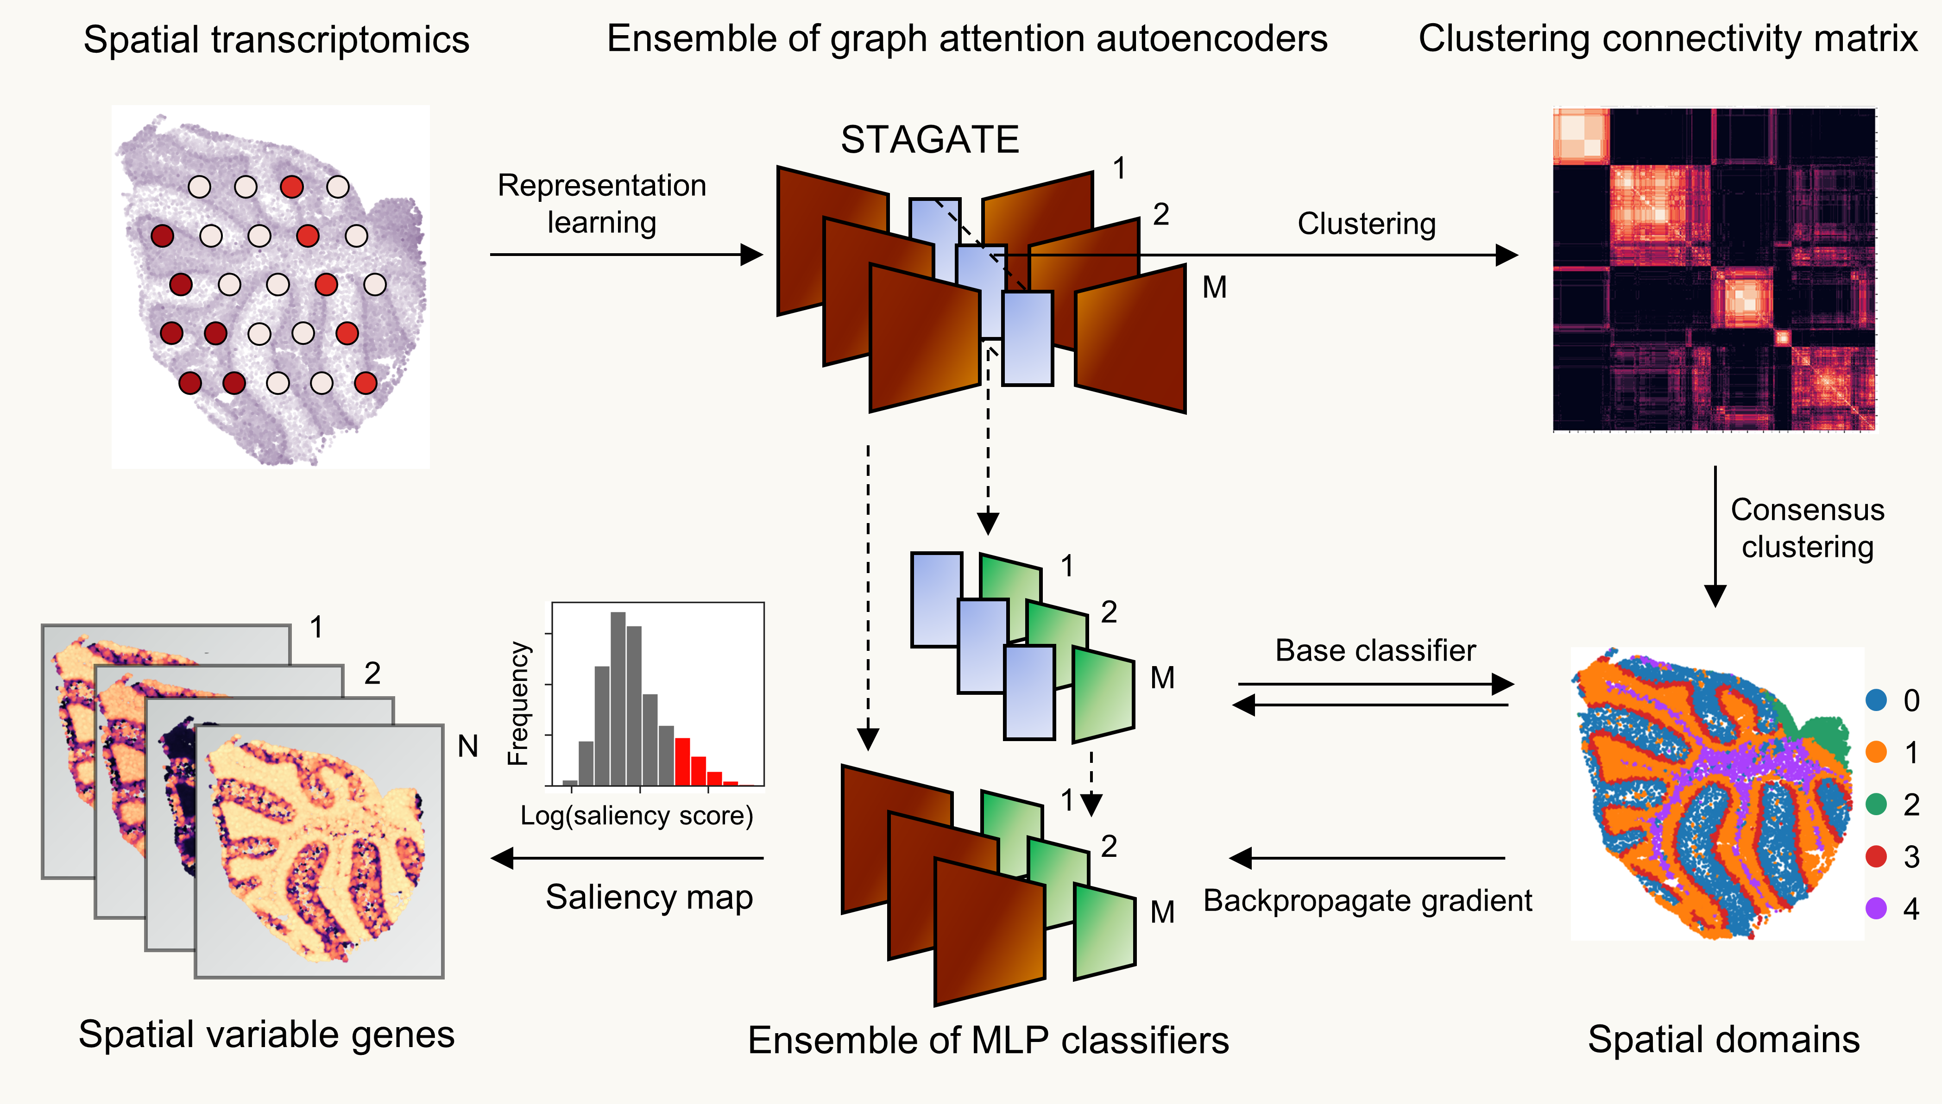

**Figure 1. Overview of STAMarker.** Given the spatial transcriptomics of a tissue section, STAMarker first trains an ensemble of graph attention auto-encoders that consists of $M$ STAGATE models to learn the low-dimensional latent embeddings of spots, cluster them to obtain $M$ grouping results, computes the clustering connectivity matrix and applies hierarchical clustering to obtain the spatial domains. STAMarker further models the relationships between the embeddings of the $M$ auto-encoders and the spatial domains by training $M$ base classifiers. At last, STAMarker computes the saliency map by first stacking the encoder and the corresponding classifier and then backpropagating the gradient to the input spatial transcriptomics matrix. STAMarker selects the domain-specific SVGs based on the genes’ saliency scores in each spatial domain.

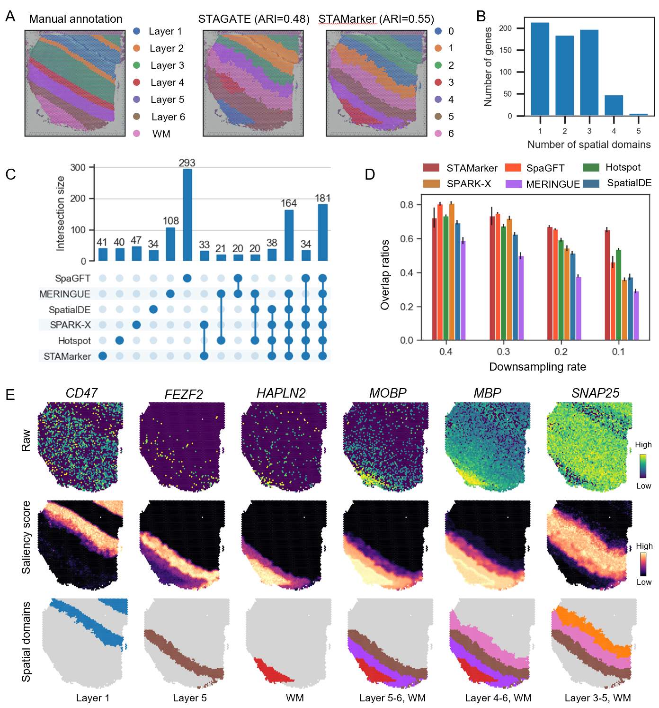

**Figure 2. STAMarker robustly identifies the spatial domain-specific SVGs on the human dorsolateral prefrontal cortex (DLPFC) dataset**. **A**, Manual annotation of cortical layers and white matter (WM) in the DLPFC section 151507, and the spatial domains identified by STAGATE and STAMarker, respectively. **B**, Histogram of the number of spatial domains to which the SVGs identified by STAMarker belong. **C**, UpSet plot of the numbers of SVGs identified by STAMarker and five compared methods. **D**, Comparison of the overlap number of the identified SVGs with the *consensus SVGs* by the six methods on the downsampled datasets. The error bars are computed based on five replicates. **E,** Visualization of the representative spatial domain-specific SVGs. From top to bottom, the raw counts, the saliency map (z-score transformation is applied), and the corresponding spatial domains of the SVGs identified by STAMarker.

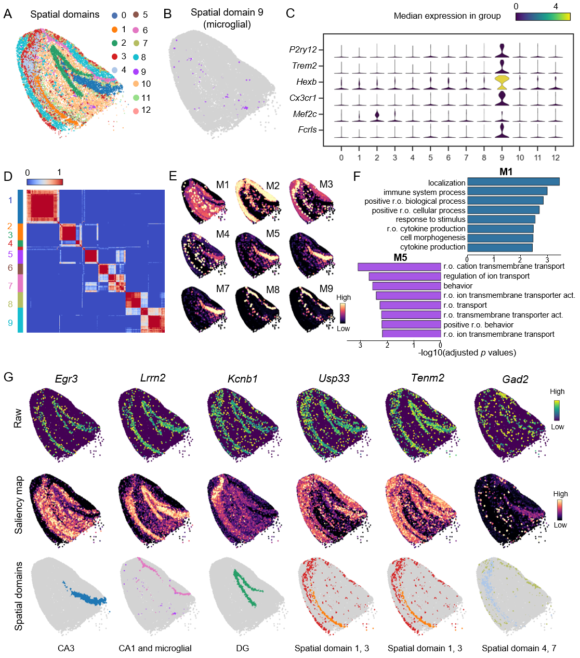

**Figure 3. STAMarker identifies spatial domain-specific SVGs on the mouse hippocampus dataset**. **A**, Spatial domains identified by STAMarker. The major subfields of the hippocampal formation, such as DG (spatial domain 2), CA1(spatial domain 6), and CA3 (spatial domain 0), were clearly shown. **B**, Spatial domain 9 corresponds to the microglial cells which are associated with the amyloid plaque of Alzheimer’s disease. **C**, Stacked violin plot showing the marker genes of microglial cells that were differentially expressed in spatial domain 9 but not others. **D**, Heatmap showing the nine clear gene modules that were clustered by the 154 spatial domain-specific SVGs. **E**, Visualization of the domain-specific gene modules by the first principal component of the saliency maps. **F**, Comparison of the top eight GO BP terms of M1 and M5. “r.o.” stands for “regulation of” to avoid clutter. **G**, Visualization of the representative spatial domain-specific SVGs. From top to bottom, the raw counts, the saliency map, and the corresponding spatial domains of SVGs.

**Figure 4**

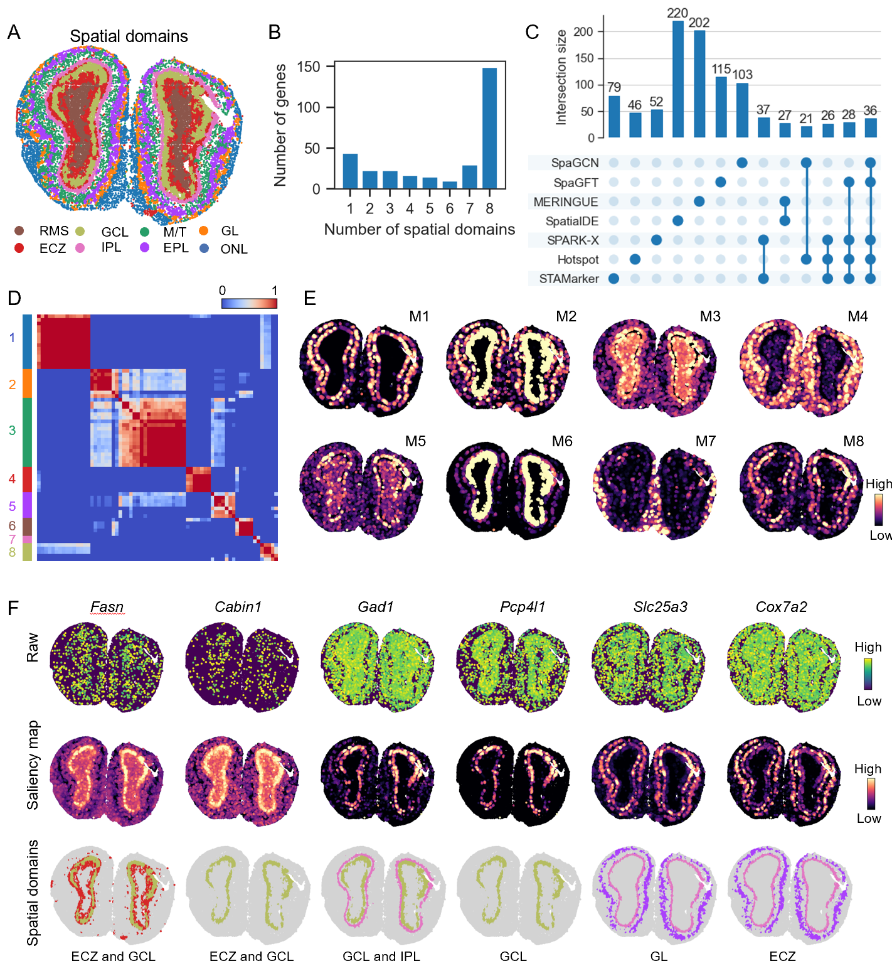

**Figure 4. STAMarker reveals the domain-specific SVGs on the mouse olfactory bulb dataset. A,** Spatial domains identified by STAMarker. The laminar organization of the mouse olfactory bulb is clearly shown. The identified spatial domains were annotated by the Allen Reference Atlas. **B**, Histogram of the number of spatial domains to which the SVGs identified by STAMarker belong. **C**, UpSet plot of the numbers of SVGs identified by STAMarker and six compared methods. STAMarker identified 311 SVGs. **D**, Heatmap showing the eight modules that were clustered by the 67 domain-specific SVGs. **E**, Visualization of the domain-specific gene modules by the first principal component of the saliency maps. **F**, Visualization of the representative spatial domain-specific SVGs.

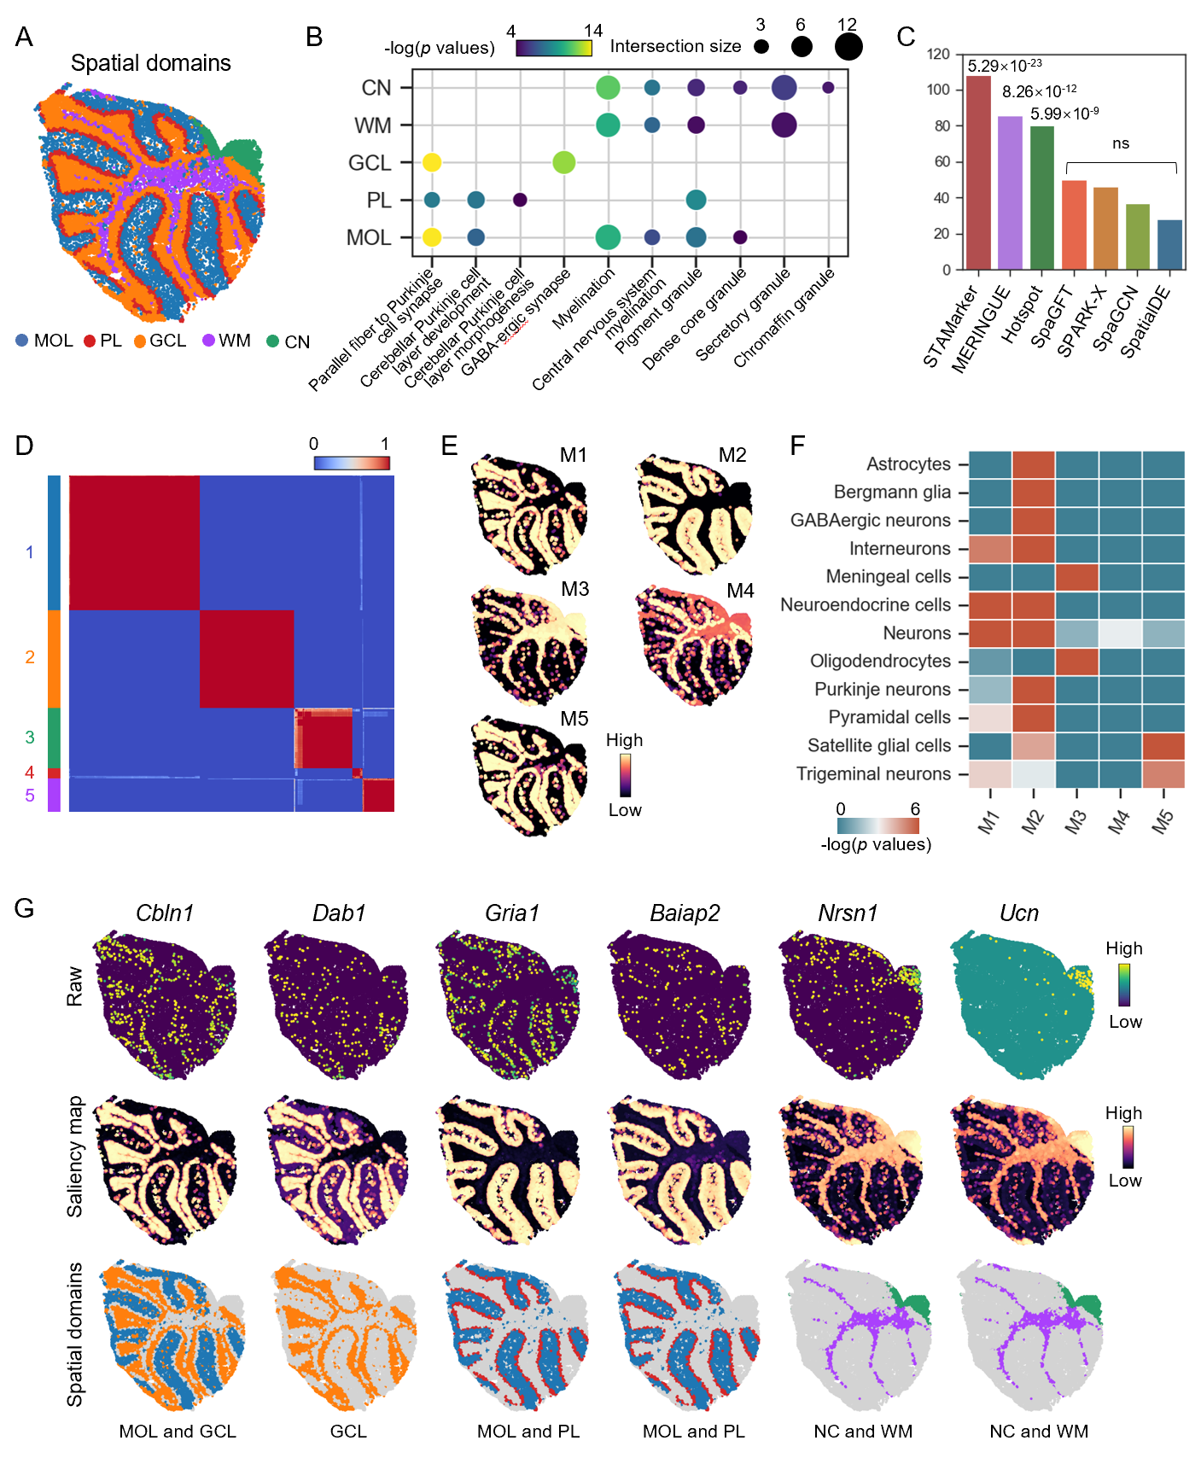

**Figure 5. STAMarker uncovers spatial domain-specific SVGs on the mouse cerebellum data. A,** Spatial domains identified by STAMarker. The identified spatial domains were annotated by the Allen Reference Atlas. **B**, GO enrichment analysis of the SVGs in the named spatial domains. The selected enriched GO terms show distinct significance levels. **C**, Bar plot displaying the overlap of the identified SVGs with reference gene list (261 genes, obtained from the Harmonizome database). The *p* values of the hypergeometric test were shown above the bars (ns indicates not significant, i.e., *p* values > 0.05). **D**, Heatmap showing the five gene modules that were clustered by the 369 domain-specific SVGs. **E**, Visualization of the domain-specific gene modules by the first principal component of the saliency maps. **F**, Enrichment analysis of the identified spatial modules with diverse cell types related to the cerebellum. **G**, Visualization of the representative spatial domain-specific SVGs.